PROJECT ROADMAP
Comparative Analysis of Time Series Forecasting Models Across Different Demand Characteristics

Domain
Data Analytics / Time Series Forecasting / Demand Analytics

Dataset
The project will use established forecasting benchmark datasets selected to expose different demand/time-series characteristics. The final experiments will be kept computationally manageable by selecting representative series from the larger datasets.
No. | Dataset | Domain | Why it is useful
1 | M5 Forecasting – Accuracy | Retail / Walmart unit sales | Primary demand dataset; daily retail sales with hierarchy, calendar and price information; useful for trend, seasonality and intermittent demand analysis.
2 | Tourism Forecasting Dataset | Tourism demand | Benchmark collection of tourism time series at yearly, quarterly and monthly frequencies; useful for seasonal and trend-driven demand.
3 | NN5 Forecasting Competition | ATM cash withdrawals / banking | Benchmark daily/weekly series with different temporal patterns; useful for variability and intermittent/irregular behaviour.
4 | Electricity | Energy demand | Large benchmark collection of electricity-demand series; useful for strong periodicity, seasonality and high-frequency demand behaviour.
5 | Dominick Sales | Sales | Large collection of weekly sales series; useful for retail/sales demand behaviour and cross-series comparison.
The Monash Time Series Forecasting Repository explicitly provides a broad research repository of real-world and competition time series and characterises datasets for forecasting research. citeturn0search0
The M5 competition provides hierarchical Walmart retail unit-sales data for forecasting daily sales, making it directly relevant to demand forecasting. citeturn0search2

Abstract
Demand forecasting is an important time-series analytics task used in retail, inventory planning, production, energy management, transportation and resource allocation. However, demand time series can exhibit different characteristics such as trend, seasonality, intermittency and variability, and these characteristics can influence the effectiveness of forecasting models. Recent research provides a wide range of statistical, machine-learning and deep-learning approaches, while benchmark studies demonstrate that forecasting performance can vary across datasets and evaluation settings. This project proposes a comparative analysis of selected established time-series forecasting models across benchmark demand-oriented datasets representing different demand characteristics.
The proposed workflow begins with data ingestion and validation, followed by data-quality checks and preprocessing. Exploratory and statistical analysis will then be used to characterize the selected series in terms of trend, seasonality, intermittency, variability and temporal dependence. A common chronological train-validation-test procedure will be used to prevent future-data leakage. Selected forecasting models, together with simple baseline methods, will be trained and evaluated using suitable forecasting error measures. The same evaluation procedure will be applied across representative datasets so that model performance can be compared under different demand behaviours.
The central research focus is not merely to identify one model with the lowest overall error, but to investigate how model suitability changes with the characteristics of the demand series. The project will therefore relate model errors and forecast behaviour to observed demand characteristics and present the findings through comparative visual analytics. The expected outcome is a reproducible empirical framework that provides evidence-based insights into which forecasting approaches are more suitable for different types of demand behaviour, while remaining feasible for systematic experimentation and future extension.

Approach
Data Analytics / Time Series Forecasting / Demand Analytics
➔ Complete Project Flow / Architecture Diagram:
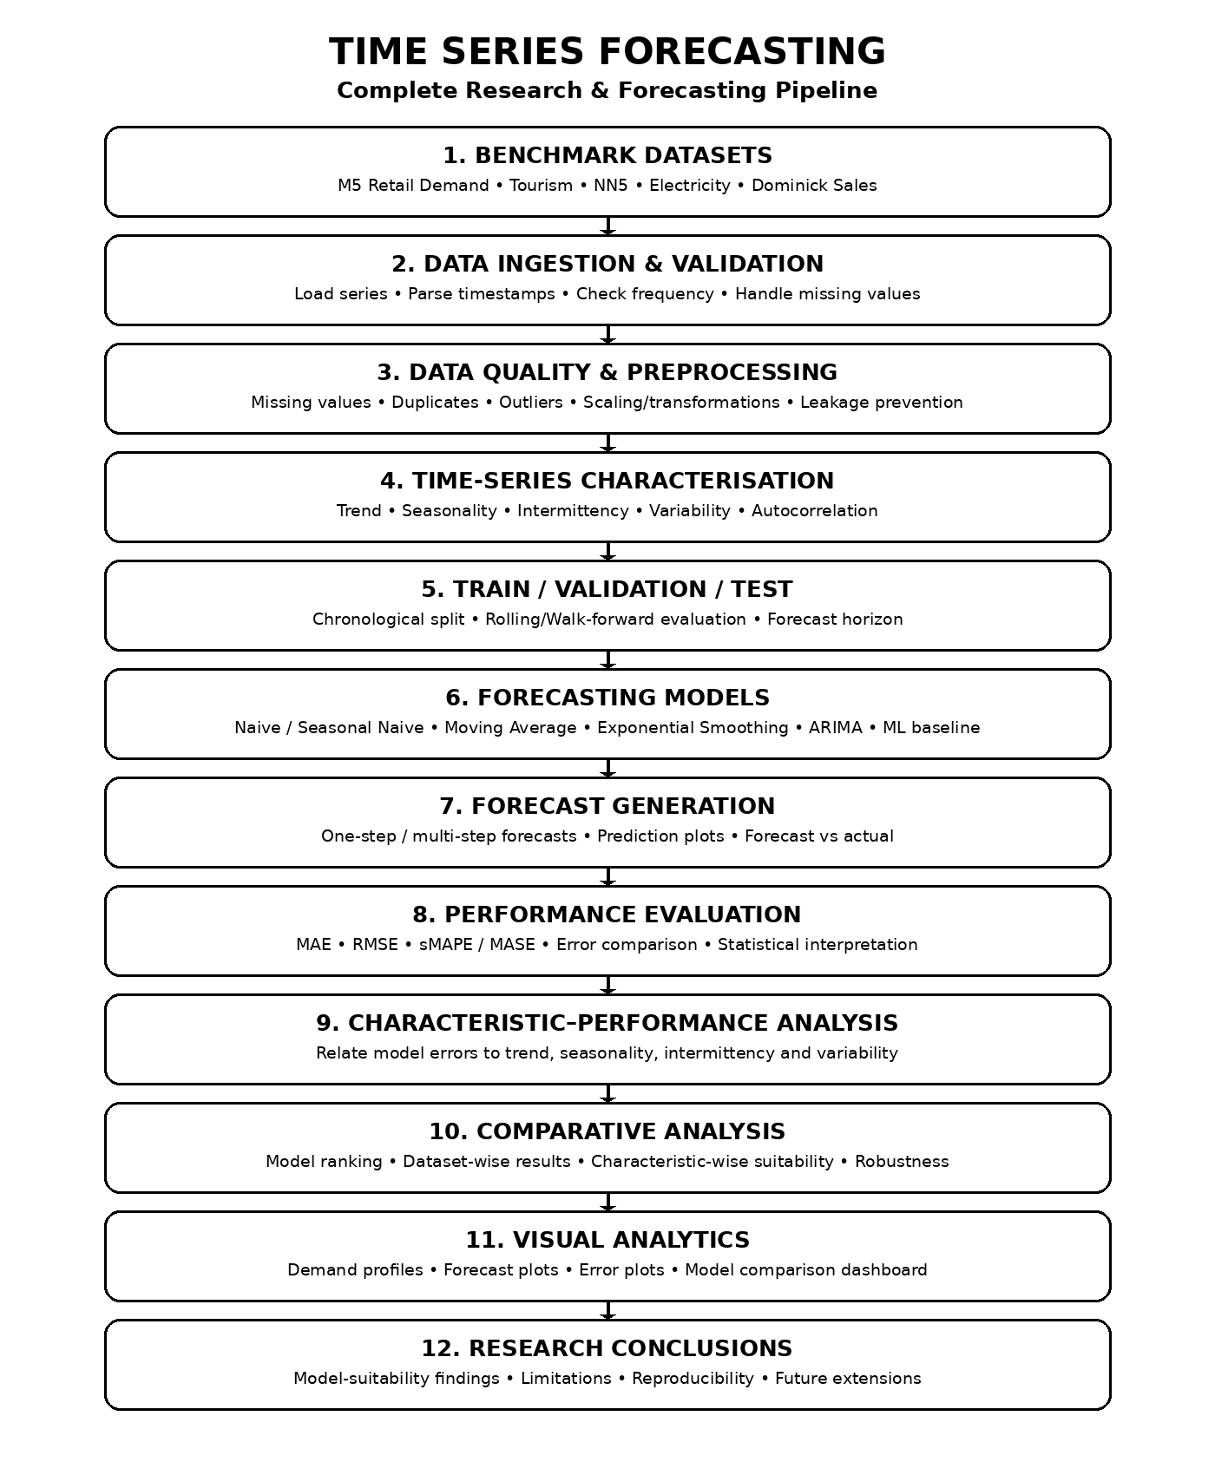
The architecture represents the complete flow from benchmark demand datasets through data preparation, time-series characterization, forecasting, evaluation, comparative analysis and research conclusions.

Data Ingestion & Preprocessing
- Dataset ingestion and schema/frequency validation.
- Timestamp ordering and duplicate-time-point checks.
- Missing-value identification and appropriate treatment.
- Outlier identification without leaking future information.
- Consistent frequency and unit handling where required.
- Transformations or scaling only where appropriate to the selected model.
- Chronological data handling to prevent future-data leakage.
- Reproducible preprocessing configuration and dataset/version tracking.

Time-Series Characterisation
The analysis will identify the characteristics that are central to the research question:
- Trend analysis — identify increasing, decreasing or changing long-term behaviour.
- Seasonality analysis — identify repeated patterns at relevant frequencies.
- Intermittency analysis — identify series containing frequent zero/low-demand periods or irregular demand occurrence.
- Variability analysis — quantify changes and fluctuations in demand.
- Autocorrelation / temporal dependence analysis — examine relationships between current and previous observations.
- Demand-profile grouping — organize representative series by observed characteristics for subsequent comparison.

Exploratory Data Analysis
EDA will go beyond basic plots and establish the reference understanding required for the forecasting experiments.
- Dataset overview and series counts
- Data-quality assessment
- Missing-value analysis
- Duplicate/timestamp analysis
- Descriptive statistics
- Outlier analysis
- Time-series plots
- Rolling mean and rolling variability
- Seasonality analysis
- Autocorrelation analysis
- Distribution analysis
- Cross-series comparison

Forecasting Models
- Naive forecasting baseline
- Seasonal Naive baseline where seasonality is present
- Moving-average baseline
- Simple Exponential Smoothing / Holt-Winters where appropriate
- ARIMA / SARIMA-family forecasting
- One manageable machine-learning forecasting baseline using lag/rolling features, if justified after the core statistical pipeline is stable
The initial implementation will prioritize established, interpretable methods. More advanced models will only be added if they strengthen the research comparison without making the project unnecessarily complex.

Performance Evaluation
- MAE — average absolute forecasting error
- RMSE — emphasizes larger errors
- sMAPE — scale-independent percentage-style comparison where appropriate
- MASE — useful for comparison against a naive benchmark across series
- Forecast-vs-actual visual analysis
- Dataset-wise and characteristic-wise error comparison
- Error distribution and robustness analysis

Comparative Analysis
The models will be compared across the following dimensions:
- Predictive accuracy
- Performance relative to simple baselines
- Behaviour on trend-dominated series
- Behaviour on seasonal series
- Behaviour on intermittent/irregular demand
- Behaviour under high variability
- Consistency across datasets
- Computational practicality and interpretability

Research Analysis
The key analysis will connect two sides of the experiment: the characteristics of the demand series and the forecasting performance obtained on those series. Instead of reporting only a single average score, the project will examine whether the relative ranking of models changes when the underlying demand behaviour changes.
- Characterise the series first.
- Run the same evaluation framework across selected models.
- Record errors at the series/dataset level.
- Group or compare results according to observed characteristics.
- Identify consistent and inconsistent model behaviours.
- Form evidence-based conclusions about model suitability.

Visualization
- Historical demand plots
- Seasonal and rolling-statistic plots
- Forecast versus actual plots
- Model error comparison charts
- Dataset-wise model ranking
- Characteristic-wise performance summaries
- Interactive or static dashboard for final presentation, if required

Recommended Research Pipeline
M5 / Tourism / NN5 / Electricity / Dominick → Data Ingestion & Validation → Data Cleaning & Preprocessing → EDA → Time-Series Characterisation → Chronological Train/Validation/Test Split → Forecasting Models → Forecast Generation → Performance Evaluation → Characteristic–Performance Analysis → Comparative Visualisation → Research Conclusions

Research Objective
The project aims not only to determine which forecasting model produces accurate predictions, but to investigate whether the suitability of established forecasting approaches changes according to the characteristics of the demand series. Using multiple benchmark datasets and a common evaluation procedure will support a transparent and reproducible comparison and allow the study to produce conclusions that are more informative than a single overall model ranking.

Key Research Position
This roadmap deliberately does not claim that comparing forecasting models is itself novel. Existing benchmark research already performs broad comparisons. The proposed contribution is the focused analysis of model suitability across different demand characteristics using a controlled, reproducible and demand-oriented experimental framework.

